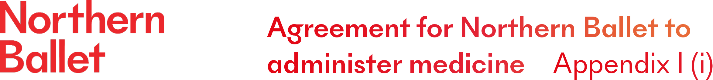
Northern Ballet will not administer medicine to anyone unless you complete and sign this form.
Name of participant:___________________________DoB:_________________Class:___________

Medical condition or illness:
Medicine
Name/type of medicine
(as described on container)
Expiry date
Dosage and method
Timing
Special precautions/other instructions
Are there any side effects that Northern Ballet needs to know about?
Self-administration – y/n
Procedures to take in an emergency

Medicines must be in the original container as dispensed by the pharmacy
The above information is, to the best of my knowledge, accurate at the time of writing and I give consent to Northern Ballet staff administering medicine in accordance with the Northern Ballet policy. I will inform Northern Ballet immediately, in writing, if there is any change in dosage or frequency of the medical (medical evidence must be provided).

If applicable, I will collect the medication at the end of the day, or at the end of the term from the Programme Manager.
Signed: _____________________________________ Date:______________________
Participant name:_______________________________________
Telephone number:_________________________________________

