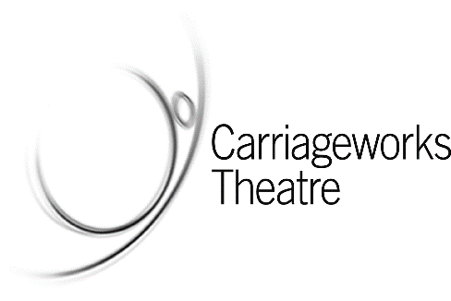

Privacy policy
Access Leeds Theatre is a partnership between Carriageworks Theatre, City Varieties Music Hall, Leeds Grand Theatre, Leeds Playhouse, Northern Ballet and Opera North. At Access Leeds Theatre we are committed to protecting your privacy. We protect any personal information you give us for the purposes of receiving our newsletters.
This policy is written in accordance with the Data Protection Act 1998. If you have any questions about it, please contact us at:

Alice Gilmour
Access Leeds Theatre
c/o Opera North
46 New Briggate
Leeds
LS1 6NU

By continuing to use our service you are signifying your agreement to the terms of this privacy policy.

Personal information
We collect personal information when you register with us to receive our newsletters by email, post or on CD. We keep your name, address, email address (if provided) and preferred format.

How do we use your information?
We use your personal information to send you the information you ask for in your preferred format. We can also use your information for administrative purposes, to let you know about changes. We will not share your information with our associated organisations (who provide the information in the newsletters).

Access Leeds Theatre is responsible for collecting your personal information. Your personal information is not shared with third parties or used in any other way (other than described in this policy or as required by law) unless you agree.

We reserve the right to share your personal information if we are legally obliged to and to enable us to apply our terms and conditions and other agreements.

Unfortunately, no data transmission over the Internet is 100 per cent secure. As a result, while we try to protect your personal information, Access Leeds Theatre cannot guarantee the security of any information you transmit to us via email and you do so at your own risk. When we collect your personal information, we use strict procedures and security features to prevent unauthorised access.

Newsletters
You can unsubscribe from Access Leeds Theatre newsletters at any time. Just click on the 'unsubscribe' link in the email you receive. Or you can contact us at

Alice Gilmour
Access Leeds Theatre
c/o Opera North
46 New Briggate
Leeds
LS1 6NU

Accessing and updating your personal information held by Access Leeds Theatre
You can ask us what information we hold about you by contacting us. And you can update your information by letting us know of any changes:

Alice Gilmour
Access Leeds Theatre
c/o Opera North
46 New Briggate
Leeds
LS1 6NU

Changes to this policy
We may change our privacy policy from time to time, so please check back periodically.

